

Basic Disaster Preparedness Plan

For Congregations and Parishes

(Parish name

(dated: mm/dd/yyyy)

Dear Episcopal Church Leaders,

Though we don’t always want to think about it, one of our roles as a church in the community is to be prepared to be of assistance after a disaster. We plan for four basic reasons:

- To mitigate the damage to our church community’s buildings and belongings;
- To be able to resume the business of the church as soon as possible post-disaster;
- To support our parishioners in times of crisis;
- To assist to our vulnerable neighbors after an emergency.

The role of Episcopal Relief & Development’s US Disaster Program is to inspire, connect and equip leaders of the US Episcopal Church to prepare for hazards that might affect their communities, as well as mitigate the impact of those disasters and help the vulnerable make a full and sustained recovery.

We recognize some congregations might not yet be ready for a full disaster planning process. The “Basic Level” template can be downloaded from the Oregon Episcopal Diocese home page http://www.diocese-oregon.org/disaster-preparedness-program/ http://www.diocese-oregon.org/disaster-preparedness-program/.

Episcopal Relief & Development’s US Disaster Program is working with dioceses around the country to help them be better prepared for emergencies. That includes training and supporting Diocesan Disaster Coordinators, who have been appointed by their bishops. A list of Diocesan Disaster Coordinators can be found on our website at www.episcopalrelief.org/usdisasterprogram. They should be your first support and resource through this planning process.

A comprehensive document, The Preparedness Planning Guide for Congregations and Parishes comes from the collected wisdom of the Church. To compile this guide, we gathered examples of parish and diocesan disaster preparedness guides from around the country as well as from other denominations. We utilized the most important elements from each, while trying to stay as simple as possible. Please let us know if there’s anything in this guide that you think should be changed, added or eliminated, and feel free to edit according to your local context.

Thanks for all you do in this important work,

Katie Mears
Director, US Disaster Program
Episcopal Relief & Development
© Copyright 2011

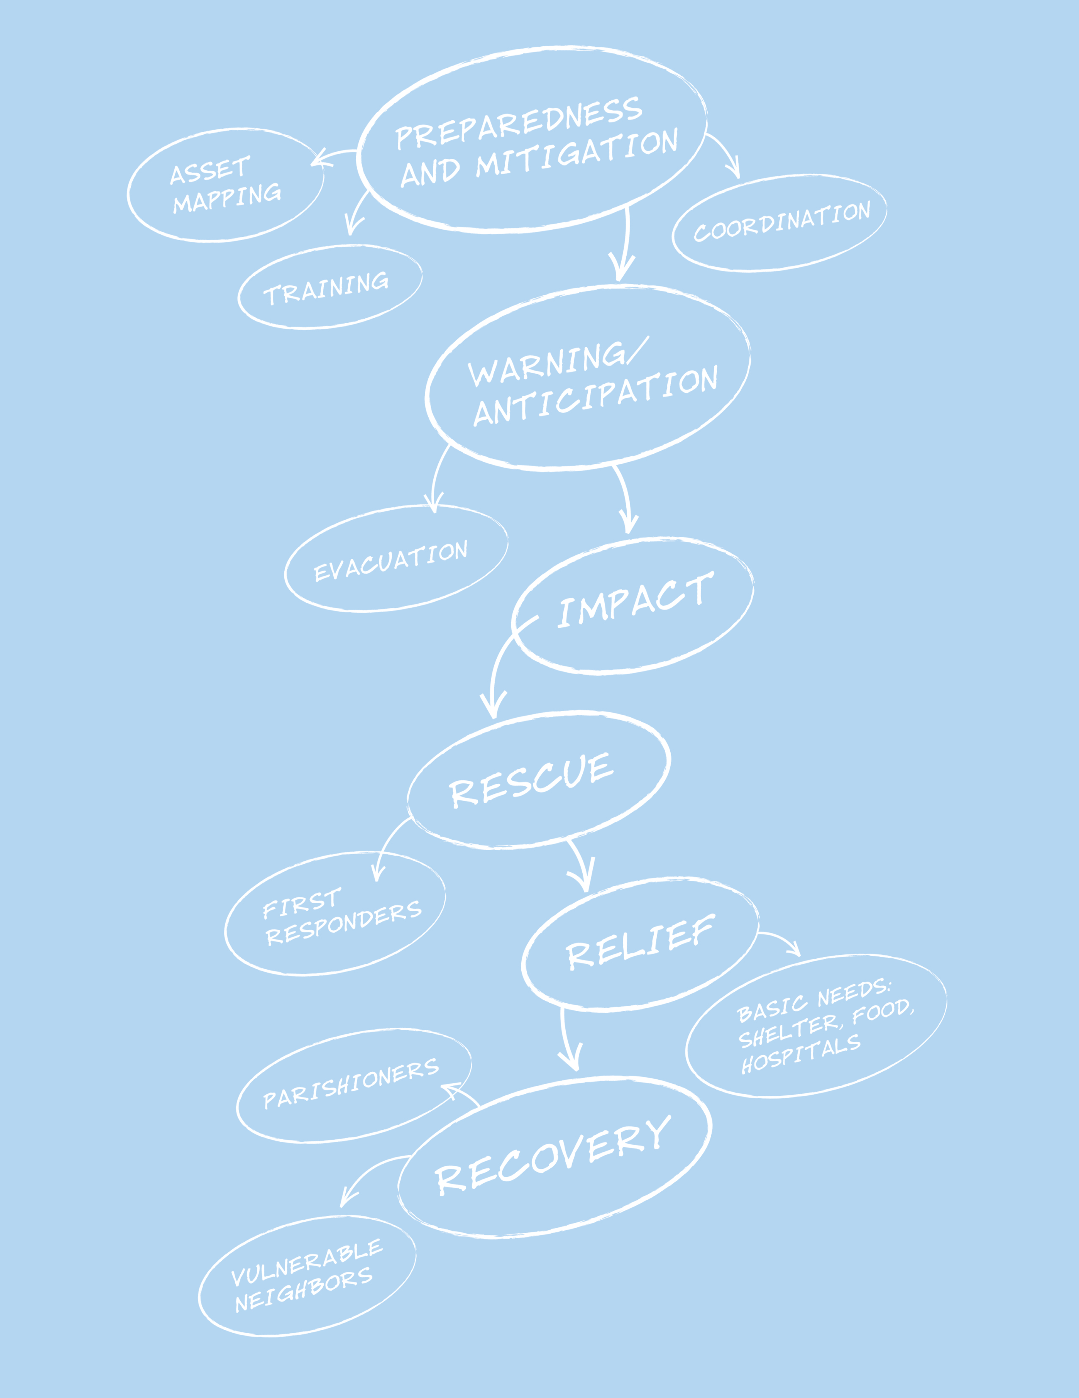

(Parish Name)

Disaster Preparedness Plan
- City:
- Phone:
- Address:
- Rector/Vicar:
- Cell Phone:
- Landline/Phone:
- Parish Emergency Coordinator:
- Cell Phone:
- Landline/Phone:
- Bishop (Diocese): | Michael Hanley
- Landline/Phone: | 503-636-5613
- Alternate Phone:
- Diocesan Disaster Coordinator: | Richard Raub
- Home phone | 503-297-2786
- Cell Phone (emergency only) | 503-833-2409
- E-mail | DDCOREGON@GMAIL.COM
- Date of Completion:
- Next Scheduled Review:

Disaster Response Leadership Team:

Contact Information

Instructions: Fill out the following form with contact information for your Congregational Disaster Coordinator and the Disaster Response Leadership Team. Even if your team consists of two people, capture their contact information.

- Parish Disaster Coordinator: | Name:
- Parish Disaster Coordinator: | Landline:
- Parish Disaster Coordinator: | Cell Phone:
- Parish Disaster Coordinator: | E-mail:
- Senior Warden: | Name:
- Senior Warden: | Landline:
- Senior Warden: | Cell Phone:
- Senior Warden: | E-mail:
- Junior Warden: | Name:
- Junior Warden: | Landline:
- Junior Warden: | Cell Phone:
- Junior Warden: | E-mail:
- Name: | Role/Designated Tasks:
- Name: | Address:
- Name: | Landline:
- Name: | Cell Phone:
- Name: | Role/Designated Tasks:
- Name: | Address:
- Name: | Landline:
- Name: | Cell Phone:
- Name: | Email:
- Name: | Role/Designated Tasks:
- Name: | Address:
- Name: | Landline:
- Name: | Cell Phone:
- Name: | Email:
- Name: | Role/Designated Tasks:
- Name: | Address:
- Name: | Landline:
- Name: | Cell Phone:
- Name: | Email:

Insurance Information

Make a list of all your insurance information and contacts. Be sure to have a copy of this information in a secure place off-site and have another copy that someone can take with them if your community is evacuated.

- Policy Number:

- Policy is with:
Phone:
Address:
- Agent:

Phone:
Address:
- Original Policy is kept:

Address:
- Copy of policy is kept offsite:

Address:
- Policy Type: | (Example – Replacement value type)
Total Value:
- Policy covers: | Earthquake, hurricane, robbery, fire, breakage, etc.
- Other policies:
- Policy review:
When:
By who:

Be sure to note where off-site copies are kept and who can access them.

Off-site Copies
- Where: | (Ex: Diocese has a copy)
- Who: | Susan Wu
Phone: | xxx-xxx-xxxx
Cell: | xxx-xxx-xxxx

Church Staff Contact Information

Instructions: Make this contact information available to your parishioners.
- Role/Job Title: Rector  Name: | Address:
- Role/Job Title: Rector  Name: | Home Phone:
- Role/Job Title: Rector  Name: | Cell Phone:
- Role/Job Title: Rector  Name: | Email:
- Role/Job Title: Rector  Name: | Emergency Contact:  - Relationship:  - Phone:
- Role/Job Title:  Name: | Address:
- Role/Job Title:  Name: | Home Phone:
- Role/Job Title:  Name: | Cell Phone:
- Role/Job Title:  Name: | Email:
- Role/Job Title:  Name: | Emergency Contact:  - Relationship:  - Phone:
- Role/Job Title:  Name: | Address:
- Role/Job Title:  Name: | Home Phone:
- Role/Job Title:  Name: | Cell Phone:
- Role/Job Title:  Name: | Email:
- Role/Job Title:  Name: | Emergency Contact:  - Relationship:  - Phone:
- Role/Job Title:  Name: | Address:
- Role/Job Title:  Name: | Home Phone:
- Role/Job Title:  Name: | Cell Phone:
- Role/Job Title:  Name: | Email:
- Role/Job Title:  Name: | Emergency Contact:  - Relationship:  - Phone:

People with Financial Authorization Approval
Instructions: Keep a copy of this information in your “Go Kit”
- Name | Phone:
- Name | Email:
- Name | Address:
- Name | Phone:
- Name | Email:
- Name | Address:
- Name | Phone:
- Name | Email:
- Name | Address:

Alternate Facilities Location

Identify the location and contact where alternate services
And office functions can be held:

- Church or Organization to Provide Alternate Location for Services: | Name:
 | Location:
 | Contact Person:
 | Telephone:
 | Alt. Telephone:
 | e-mail:
 | Person who established alternate:
 | Where communion items are stored, e.g., wafers, chalices.
- Location Where Church Business Can Continue: | Name:
- Location Where Church Business Can Continue: | Location:
- Location Where Church Business Can Continue: | Contact Person:
- Location Where Church Business Can Continue: | Telephone:
- Location Where Church Business Can Continue: | Alt. Telephone:
- Location Where Church Business Can Continue: | e-mail:
- Location Where Church Business Can Continue: | Person who established alternate:

Identifying Groups that Include or Serve Vulnerable People

People with special needs will be at higher risk during a disaster. Take the time to identify those people within your congregation, and brainstorm what problems they may face and how you could help with those problems as a congregation.

Instructions: List the groups in the parish that are either comprised of or serve people who might be especially vulnerable after a disaster. These might include senior citizens’ groups, groups for new mothers, and religious education programs that include children with special needs. List the contacts for each group, so that they can be contacted after a disaster to help assess needs and facilitate the response.

Group | Contact | Types of needs members might have.
The Senior Citizens Club is comprised of parishioners aged 65 and older. | Betty Jones  503-555-1212 | Difficulty evacuating. Medical conditions.
The Lay Eucharistic Visitors have a current list of people who are home-bound or who are in the hospital. | Deacon Williams  503-555-1212 (cell) | Difficulty evacuating. Medical conditions.

Secure Storage of Records and Archives (print and electronic)

Appropriate protection of records is essential. If your paper files are charred or water-damaged, or your computer files are lost, you may need to hire professional recovery companies in addition to rebuilding the data. Archival items by nature are irreplaceable.

Refer to the “Records Manual for Congregations” published by the Archives of the Episcopal Church for a list of records to retain and the time to retain them. You can also find this information at: http://www.episcopalarchives.org/Records_Manual_for_Congregations.pdf

- Every congregation needs a fireproof, waterproof, quake-proof lockable box or safe (or safety deposit box). All historical items, valuables and the following should be kept in the safe and preferably digitized. Digitize and photocopy irreplaceable records and store offsite:
- Parish registers and service books – at all times when not in use
- Confidential records: personnel files, documents displaying social security numbers, and confidential counseling records.
- Contracts, mortgage or loan papers, titles and deeds, other legal documents, etc.
- Paper records and files
- These could include your administrative, financial, and ministry files, and copies of print newsletters or bulletins. Store them in metal file cabinets, preferably not on opposite walls from windows. Digitize and store at an offsite server.
- Archives
- These are best stored in temperatures between 65-68 degrees, with 45% humidity, in metal cabinetry or shelved in acid-free boxes, in a closed room with no windows. If the room is fireproofed, even better. After fire, water and mildew are the worst enemies.
- Inventory your archives carefully and keep a copy offsite.
- Software and electronic files
- Keep anti-virus and spyware protection up to date, establish protocols for office computer use including password protection, and use a surge protector
- Back-up your office files regularly and keep back-ups in a secure location off-site.
- Keep your original software CDs in the safe.
- Make backups of your website. Make sure your web-hosting provider regularly backs up their servers and protects the data. Consider a web-hosting service with multiple servers in various locations nationally.
- Keep a list of passwords and usernames for all computers in the church safe/safety deposit box/off-site. Make sure this information is kept in at least 2 places and persons, and there is a copy in your “Go Kit.” This will help to ensure access to them after a disaster
- Diocesan archive storage
- Provide copies of your architectural drawings and asset inventories to the diocesan archives.

Secure Storage of Records and Archives (print and electronic)

- Location of Offsite Office Records:
Digital? YES NO
If password protected, names of individuals holding passwords

- Location of Offsite Financial Records:
Digital? YES NO
If password protected, names of individuals holding passwords

- Location of Offsite Church Records:
Digital? YES NO
If password protected, names of individuals holding passwords

- Photographic/Video Inventory of Assets
Digital? YES NO
If password protected, names of individuals holding passwords

- Updating Policy | (indicate – daily, weekly, monthly, annually)
Offsite Office Records
Offsite Financial Records
Offsite Asset Records
Photographic/Video Records
- Other Notes Regarding Records:

Diocesan Contact Information

Instructions: Change, remove and add titles as relevant to your diocese.
- Bishop  Michael Hanley | Address: | 11800 SW Military Lane, PDX, 97219
- Bishop  Michael Hanley | Office Phone: | 503-636-5613
- Bishop  Michael Hanley | Cell Phone:
- Bishop  Michael Hanley | Alt Phone: | 888-346-2373
- Bishop  Michael Hanley | Email: | bishop@episcopaldioceseoregon.org
- Canon to the Ordinary  Neysa Ellgren | Address: | 11800 SW Military Lane, PDX, 97219
- Canon to the Ordinary  Neysa Ellgren | Office Phone:
- Canon to the Ordinary  Neysa Ellgren | Cell Phone:
- Canon to the Ordinary  Neysa Ellgren | Home Phone:
- Canon to the Ordinary  Neysa Ellgren | Email: | neysa@diocese-oregon.org
- Executive Assistant to the Bishop  Marie Bagwell | Address: | 11800 SW Military Lane, PDX, 97219
- Executive Assistant to the Bishop  Marie Bagwell | Office Phone: | 971-204-4116
- Executive Assistant to the Bishop  Marie Bagwell | Cell Phone:
- Executive Assistant to the Bishop  Marie Bagwell | Home Phone:
- Executive Assistant to the Bishop  Marie Bagwell | Email: | marieb@diocese-oregon.org
- Minister for Latino Ministries  Roberto Arciniega | Address:
- Minister for Latino Ministries  Roberto Arciniega | Office Phone: | 503-910-6006
- Minister for Latino Ministries  Roberto Arciniega | Cell Phone:
- Minister for Latino Ministries  Roberto Arciniega | Home Phone:
- Minister for Latino Ministries  Roberto Arciniega | Email: | betoa@diocese-oregon.org
- Diocesan Disaster Coordinator  Richard Raub | Address: | 1136 SW Washington St, PDX, 97225
- Diocesan Disaster Coordinator  Richard Raub | Office Phone: | --
- Diocesan Disaster Coordinator  Richard Raub | Cell Phone (emergency only): | 503-833-2409
- Diocesan Disaster Coordinator  Richard Raub | Home Phone: | 503-297-2786
- Diocesan Disaster Coordinator  Richard Raub | Email: | DDCOregon@gmail.com
- Communications Director  JT Quanbeck | Address: | 11800 SW Military Lane, PDX, 97219
- Communications Director  JT Quanbeck | Office Phone:
- Communications Director  JT Quanbeck | Cell Phone: | 971-204-4108
- Communications Director  JT Quanbeck | Home Phone:
- Communications Director  JT Quanbeck | Email: | jtq@diocese-oregon.org
- Other  Name: | Address:
- Other  Name: | Office Phone:
- Other  Name: | Cell Phone:
- Other  Name: | Home Phone:
- Other  Name: | Email:

The safe should have a rating of 4 to 5. If the safe is on a basement floor, it’s recommended that you keep it 6-8 inches above the floor on a concrete or durable slab.
Description of the “Go Kit” appears on page 27 of the “Comprehensive Preparedness Planning Guide for Congregations” found on the Oregon Episcopal Diocese website under Disaster Preparedness Program, http://www.diocese-oregon.org/disaster-preparedness-program/ “Templates and Aids”
Suggestions for conducting photographic and video inventories and their updating are found in a document Photographic and Video Inventory of Church Assets located on the Oregon Episcopal Diocese website, “Resources”, “Disaster Preparedness Program,” http://www.diocese-oregon.org/disaster-preparedness-program/ “Resources” (under development)

